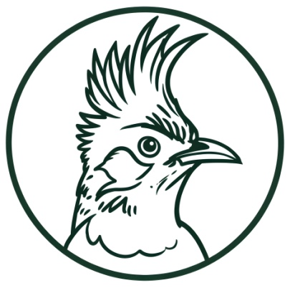
The_Birds_Vet
Trust of India

https://www.thebirdsvet.org.in/

Founders

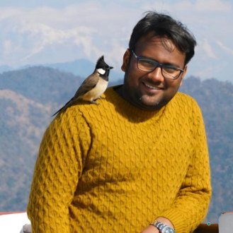
Dr. Beerendra Kumar Verma
Founder & President
The visionary behind The_Birds_Vet Trust of India. And a passionate advocate for avian health and welfare, he is dedicated to improving the lives of birds through compassionate care, awareness, and scientific guidance. His vision and commitment have been instrumental in building a platform that promotes responsible bird care and conservation across India.
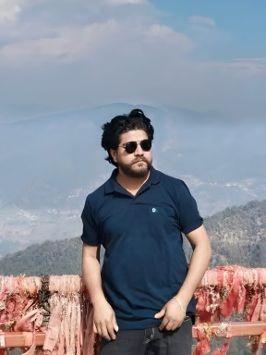
Dr. Vijay Kumar
Co-founder/Director
He is a dedicated professional committed to advancing knowledge and service in his field. With a strong sense of responsibility and a passion for making a meaningful impact, he consistently works toward improving lives through his expertise and thoughtful approach.

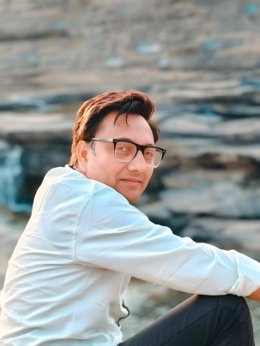
Rohit Kumar
Co-founder/Treasurer
He is a passionate and dedicated individual who believes in creating a positive impact through his work and values. With a strong sense of responsibility and a forward thinking mindset, he consistently strives to grow, learn, and contribute meaningfully to the people and environment around him.


Swati Verma
Co-founder/Vice President/ Trustee
She is a Co-founder, Vice President, and Trustee whose dedication and compassion form the heart of the organization. As a founding pillar, she has played a vital role in shaping the vision of The_Birds_Vet Trust of India, working tirelessly to build a caring and supportive community for bird welfare.
With a nurturing spirit and a deep sense of responsibility, she believes in creating awareness, spreading kindness, and ensuring that every bird receives the care and respect it deserves. Her commitment continues to inspire positive change and strengthen the mission of the trust.

Technical Advisory Board

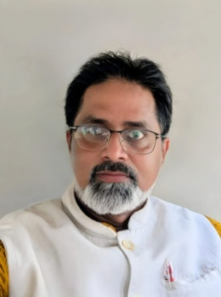
Dr. Sushant Srivastava
Senior Avian Reproductive & Breeding Consultant
Professor and Head
Department of Veterinary Gynaecology
and Obstetrics
CVSc&AH, Acharya Narendra Deva University Of Agriculture And Technology, Kumarganj, Ayodhya (UP) 224229

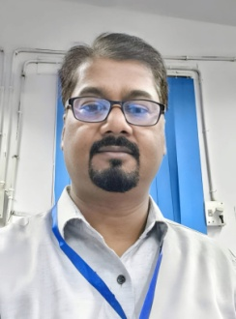
Dr. Rishikant
Senior Avian Health & Toxicology Consultant
Assistant Professor
Department of Veterinary Pharmacology and Toxicology
CVSc&AH, Acharya Narendra Deva University Of Agriculture And Technology, Kumarganj, Ayodhya (UP) 224229

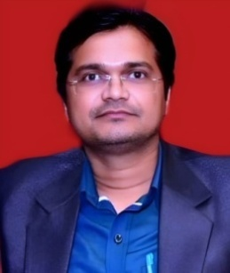
Dr. RP Diwakar
Avian Microbiology Consultant
Assistant Professor (SS)
Department of Veterinary Microbiology
CVSc&AH, Acharya Narendra Deva University Of Agriculture And Technology, Kumarganj,
Ayodhya (UP) 224229

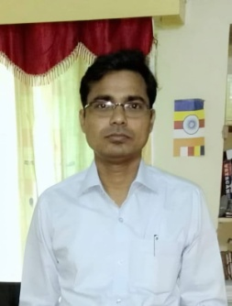
Dr. Rajesh Kumar
Associate Avian Reproductive & Breeding Consultant
Assistant Professor
Department of Veterinary Gynaecology
and Obstetrics
CVSc&AH, Acharya Narendra Deva University Of Agriculture And Technology, Kumarganj, Ayodhya (UP) 224229

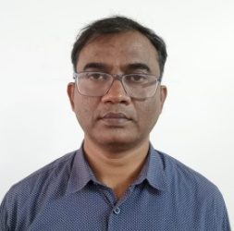
Dr. Laxmi Prasad
Aquatic Avian Conservation Consultant
Professor and Head
Department of Aquaculture
College of Fisheries Science, DUVASU, Mathura (UP) 281001

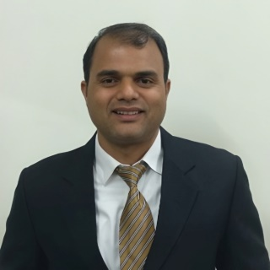
Dr. Brijesh Kumar
Senior Avian Reproductive & Breeding
Consultant
Senior Scientist
ICAR-Indian Veterinary Research Institute
Bareilly (UP) 243122

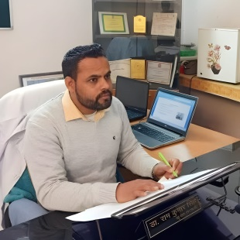
Dr. Ram Kumar Singh
Associate Avian Nutrition Consultant
Assistant Professor
Department of Livestock Farm Complex
Animal Nutrition
COVAS, SVPUAT, Meerut (UP) 250110

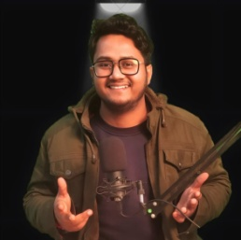
Board Members
Mr Abhishek Verma
Technology Head & Admin
He serves as the Technology Head & Admin, ensuring smooth digital and administrative operations. He manages technical systems and supports the organization with innovative solutions. With strong leadership skills, he streamlines processes for better efficiency. His dedication strengthens the organization’s technological growth and management.

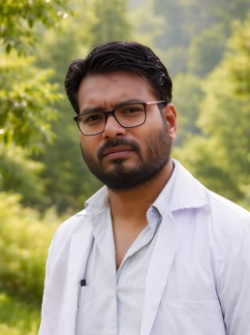
Dr. Anoop Kumar Shastri
Deputy Director
He is a dedicated professional known for his commitment to public service and leadership. He serves with responsibility and integrity, contributing effectively to administrative and community development work. With a strong vision and practical approach, he ensures efficient implementation of policies and initiatives. His dedication reflects a continuous effort to bring positive change and better governance.

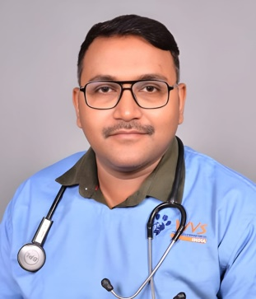
Dr. Sachin Kumar Yadav
Deputy Director (Bareilly) UP
Vet. Physician and Surgeon
SACHIN VETS DOG & CAT CLINIC
Bareilly (UP)

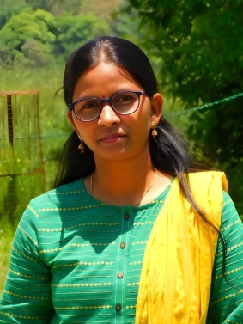
Vandana Verma
Trustee/Bird Energy Conservation Coordinator
Assistant Teacher
Upper Primary School
She is committed to the welfare and protection of avian life. She actively contributes to initiatives that promote awareness and sustainable practices for bird conservation. Alongside her environmental work, she serves as an Assistant Teacher at an Upper Primary School, shaping young minds with care and knowledge. Her balanced commitment to education and nature reflects her passion for creating a better future for both people and avian life.

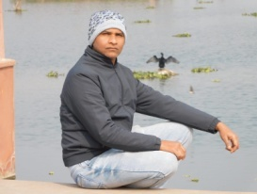
Mr Abhilash Verma
Bird Care Coordinator
He is a committed Bird Care Coordinator dedicated to the welfare and protection of birds. He actively manages rescue, care, and rehabilitation efforts with responsibility and compassion. His hands-on approach ensures that injured and distressed birds receive proper attention and support. His dedication reflects a deep passion for avian care and wildlife conservation.

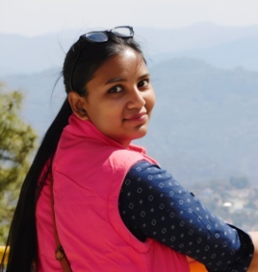
Shweta Verma
Aquatic Avian welfare Coordinator
She is a dedicated and compassionate individual committed to making a positive impact in her field. She brings enthusiasm and sincerity to her work, consistently striving for excellence.
With a caring nature, she supports initiatives that contribute to community well-being. Her passion and dedication reflect her vision for creating meaningful change.

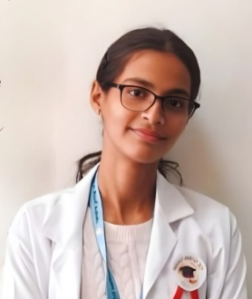
Anchal Verma
Avian Care Coordinator
She is playing a vital role in managing and supporting avian rescue and care activities. With a strong sense of responsibility, she ensures proper rehabilitation of birds in need.

